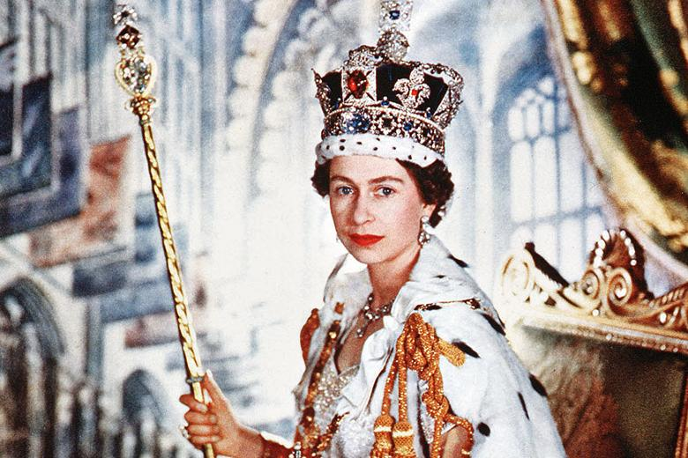

SPECIAL EVENT
The Parish of Trinity ‘Three in One’ Senior Citizens Club, invite ALL senior citizens of the Parish to join them on 1st June 2022 at 2pm at Trinity Youth & Community Centre.
There will be a screening of a film of the 1953 Coronation of Queen Elizabeth II,
followed by afternoon tea, kindly sponsored by Mr & Mrs Paul Bell.

Non-members of the ‘Three in One’ RSVP to Parish Hall on 865345 to reserve a place.

